Bottleneck-Enabler Focus Group
Purpose: This document can be used to retrospectively reflect on the bottlenecks and enablers associated with a specific event detected through an event-based surveillance (EBS) system. The document is organized by each early warning, alert, and response (EWAR) step with indicators and questions at each step. This analysis can be used to help identify recommended actions to help improve an EBS system.
Bottlenecks and enablers are factors that, respectively, prevent or facilitate timely action during an event. Individuals directly involved in the initial detection and response of an event should be gathered for a participatory session to discuss bottlenecks, enablers and their root causes. Draw from this document and the question pool document to administer focus group questions. Make sure to ask follow-up questions and follow interesting trains of thought with additional probes. Following the focus group, analyze notes, recordings, and/or transcripts from the focus group to analyze bottlenecks and enablers. These bottlenecks and enablers may be technical, operational or political. When identifying bottlenecks, ensure that they are clear, and root causes are determined so these can later be addressed. Examples of clear bottlenecks are provided below.
Table 1: Characteristics of a Clear Bottleneck
Characteristics of a Clear Bottleneck | Unclear Bottleneck | Clear Bottlenecks
- Phrased in specific terms  - Defines the root cause of an observed delay  - Focuses on systemic issues and avoids individual blame or complaints | “Shortage of staff” | Took 2 days for the community health worker supervisor to review and triage all the signals reported by the community” cx“

Focus group tips:
Focus groups involve interviewing multiple participants in a group setting. They are effective in eliciting data on cultural norms of a group and generating a broad overview of issues of concern to the groups or subgroups represented. Here are some tips on planning a focus group:
- Carefully planned discussion designed to elicit perceptions of a defined topic in a permissive, non-threatening atmosphere
- Group dynamics stimulate shared experiences and cognitive triggers
- Used to study social norms, group dynamics and processes
- Participants don’t know each other but are similar
- Comfortable atmosphere is key—need highly skilled facilitators
- Moderator and note-taker teamwork is key. Decide whether you will be recording the focus group, as well.

Below is a list of the different categories for Bottlenecks and Enablers adopted from 7-1-7 alliance. If an item described fits neither of these categories, just write ‘other’ and describe as best you can. Table 2 lists examples of bottlenecks, enablers would just be the opposite.
Table 2: Example Bottleneck and Enabler Categories
Categories | Example Bottlenecks
Staffing | Shortage in staff, inadequate training
Coordination | Lack of contact numbers to enable coordination among ministry of health and partners
Data Systems | Faulty information system not recording data, lack of interoperability, lack of electronic data system, incomplete surveillance data
Event Characteristics | Site access issues, new or unexpected pathogen, wide-spread and poorly characterized event
Patient & Community | Delay in care-seeking by patient, community members unaware of hotline number
Planning & Procedures | Lack of adherence to SOPs and EWAR procedures
Policy | Delayed approvals, lack of government policy & regulations
Resources & Procurement | Lack of funding, inadequate supplies, power outage

Figure 1: Suggested Timepoints for the Event-Based Surveillance Process
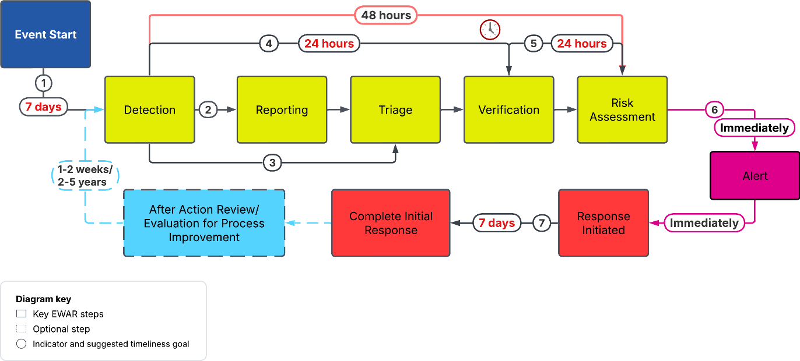
*Note: Monitoring occurs throughout the whole process.

Focus Group Tool
Event Name: _________________________________ Event Location: __________________________
Risk Level: _______________________________ Today’s Date: ___________________________
Step 1: Record EBS Process Dates
EWAR Steps | Date  (MM/DD/YYYY) | Narrative  (How was the date determined?)
Event Start
Detection
Reporting
Triage
Verification
Risk Assessment
Alert
Response Start
Initial response completion

Step 2: Calculate Timeliness Intervals

Indicator | Time Taken | Suggested Time | Target Met?
- Timely Detection |  | 7 days
- Timely Reporting |  | <1 day
- Timely Triage |  | <1 day
- Timely Verification |  | 1 day
- Timely Risk Assessment |  | 1 day
- Timely Alert |  | 1 day
- Timely Response |  | 7 days

Event-Based Surveillance and EWAR System Questions
Below are the questions that you can ask at each step of the EBS/EWAR process to get an understanding of the bottleneck and enablers. This section asks about the event context in relation to each step and can be helpful background to discuss prior to listing bottlenecks and enablers and is optional.
Question | Answer (Provide as much detail as possible)
Detection
Where did the initial signal for this event come from? How was this reported and from where? E.g. source & geographical location
Are there any unique features where the event came from? E.g. remote area, high-density, refugee population
How was this signal detected? Explain the process, modality, and note if this is the typical way that signals are detected.
Where was this signal recorded? Paper form/electronic system and is this the typical way signals are recorded?
What were the next steps that took place after this signal was detected?
Triage
Explain how this signal was triaged. Is this the typical process taken for triage?
Which signal definition did this signal match with?
What were the next steps that took place after this signal was triaged?
Verification
Explain how this signal was verified. Is this the typical process taken for verification?
What were the next steps that took place after this signal was verified as an event?

Risk Assessment
Explain how the rapid risk assessment was conducted for this event? Is this the typical process?
What tool was used and what was the outcome? Does your tool include an assessment of hazard, exposure, context?
Did you gain new information about the event after conducting the initial rapid risk assessment? If yes, was the risk assessment updated?
What were the next steps that took place after the rapid risk assessment?
Alert
Explain how the alert was issued for this event? Who and how were they contacted? Was the process automated? Did this reflect the typical alert process?
What were the next steps that took place after the alert was issued?
Response
Explain how the event was initially responded to? What were the immediate actions taken? Did this reflect the typical response process?
How long did the response take overall before the event was declared closed? What were the most impactful response actions that led to the control of the event?

Step 3: This table is meant to help compile the bottleneck and enablers identified at each interval.
Interval | Bottlenecks  Factors that prevented timely action. | Enablers  Factors that enabled timely action.
Detection
Triage
Verification
Risk Assessment
Alert
Response

Step 4: Based on the ideal situation, how would you improve the EBS component of the EWAR workflow to ensure timely response? Identify the priority action items that should be taken in the short-term (less than 6 months) to help improve your system.
Interval | Action Items | Person responsible for leading change efforts? | Target Implementation Date
Detection | 1.  2.  3.
Triage
Verification
Risk Assessment
Alert
Response

Glossary
Date of Event Start (synonym: Date of Emergence): defined by the GPW13, the ideal date is the date of the index case symptom onset. Alternative measures could include symptom-onset date of first reported case (=initial case); first visit to health-care facility; suspected primary case; most likely exposure date (estimated); first exposure date (estimated); latest exposure date (estimated); outbreak start date; date of death of first reported case (=initial case); first report of the outbreak. 7-1-7 further elaborated that for endemic diseases this is the date on which a predetermined increase in case incidence over baseline rates occurred; for non-endemic diseases this is the date on which the index case or first epidemiologically linked case first experienced symptoms; and for other public health events this is the date the threat first met criteria as a reportable event based on country reporting standards
Date of Event Detection: defined by the GPW13⁴⁶, the ideal date is the date local health authorities detect the event. Alternative dates to consider include, first confirmatory laboratory test; first sample collection date; MoH press release date; rapid diagnostic test (RDT) date; first time diagnosed as suspected case; date other external party reported to MoH; date outbreak declared; date local health authority reported to MoH; preliminary laboratory test; communication from laboratory to MoH; date first communication between third party Member States happened; and date local health authority detected signal through media.
Date of Event Response: Earliest date of any public health intervention to control the event including date field investigation started; incident management system set up; vaccination campaign started; active surveillance initiated; rapid response team deployed; active surveillance initiated; risk communication started; date quarantine started; vector control campaign launched; food/product recall started; national emergency operation centre (EOC) activated; and expert group established.
Date Initial Response Completed: according to 7-1-7³⁸, this is the date on which all applicable early response actions were completed including, initiating and investigation or deploy investigation/response team; conducting an epidemiologic analysis of burden, severity and risk factors, and performing an initial risk assessment; obtaining laboratory confirmation of the outbreak etiology; initiating appropriate case management and infection prevention and control (IPC) measures in health facilities; initiating appropriate public health countermeasures in affected communities; initiating appropriate risk communication and community engagement activities; and establishing a coordination mechanism.

For more information on Bottleneck Categories, visit 7-1-7 Alliance
See the 7-1-7 Alliance materials for more information on initial response activities. These include staff deployment for an initial investigation, laboratory diagnosis, EOC activation, establishing risk communication and clinical management protocols.
See the “Bottleneck-Enabler Focus Group Calculations” Excel Spreadsheet to help simplify calculations.
World Health Organization Rapid Risk Assessment of Acute Public Health Events has further details on questions to ask about hazard, exposure, and context.

